Product Features
- Supports 1.25Gbps/1.0625Gbps bit rates
- Bi-Directional SC/PC connector
- Hot pluggable SFP footprint
- 1490nm DFB laser and 1550nm APD photo detector
- 1550nm DFB laser and 1490nm APD photo detector
- 37dB link budget for up to 160km transmission on G.652 SMF
- Low power consumption, < 1.0W
- Digital Diagnostic Monitor Interface
- Compliant with SFP MSA and SFF-8472
- Very low EMI and excellent ESD protection
- Operating case temperature: Commercial:0 to 70 °C
Industrial:-40 to 85 °C

Applications
1
- Gigabit Ethernet
- Fiber Channel
- Switch to Switch interface
- Switched backplane applications
- Router/Server interface
- Other Optical Links

Ordering Information
Part Number | Output Power | Rec. Sens | Data Rate | Wavelength | Distance
FH-SB4512CDS120 | 3 ~ 7 db | -34db | 1.25G | TX1490/RX1550nm | 160km

General

FH-SB4512CDS160 SFP-BIDI transceivers are high performance, cost effective modules supporting dual data-rate of 1.25Gbps/1.0625Gbps and 120km transmission distance with SMF.The transceiver consists of three sections: a DFB laser transmitter, a PIN photodiode integrated with a trans-impedance preamplifier (TIA) and MCU control unit. All modules satisfy class I laser safety requirements. The transceivers are compatible with SFP Multi-Source Agreement (MSA) and SFF-8472. For further information, please refer to SFP MSA.

Absolute Maximum Ratings
Parameter | Symbol | Min. | Max. | Unit | Note
Supply Voltage | Vcc | -0.5 | 4.0 | V
Storage Temperature | Ts | -40 | 85 | °C
Relative Humidity | RH | 0 | 85 | %
Note: Stress in excess of the maximum absolute ratings can cause permanent damage to the module

General Operating Characteristics
Parameter | Symbol | Min. | Typ | Max. | Unit | Note
Data Rate | DR |  | 1250 |  | Gb/s
Supply Voltage | Vcc | 3.13 | 3.3 | 3.47 | V
Supply Current | Icc₅ |  |  | 220 | mA
Operating Case Temp. | Tc | 0 |  | 70 | °C
Operating Case Temp. | TI | -40 |  | 85 | °C

Electrical Input/Output Characteristics
Parameter |  |  | Symbol | Min. | Typ | Max. | Unit | Note
Transmitter
Diff. input voltage swing |  |  |  | 200 |  | 2000 | mVpp | 1
Tx Disable input | H |  | VIH | 2.0 |  | Vcc+0.3 | V
Tx Disable input | L |  | VIL | 0 |  | 0.8 | V
Tx Fault output | H |  | VOH | 2.0 |  | Vcc+0.3 | V | 2
Tx Fault output | L |  | VOL | 0 |  | 0.8 | V | 2
Input Diff. Impedance |  |  | Zin |  | 100 |  | Ω
Receiver
Diff. output voltage swing |  |  |  | 400 |  | 1600 | mVpp | 3
Rx LOS Output |  | H | VOH | 2.0 |  | Vcc+0.3 | V | 2
 |  | L | VOL | 0 |  | 0.8 |  | 2
Notes:
1. TD+/- are internally AC coupled with 100Ω differential termination inside the module.
2. Tx Fault and Rx LOS are open collector outputs, which should be pulled up with 4.7k to 10kΩ resistors on the host board. Pull up voltage between 2.0V and Vcc+0.3V.
3.RD+/- outputs are internally AC coupled, and should be terminated with 100Ω (differential) at the user SERDES.

Optical Characteristics
1111
Parameter | Symbol | Min. | Typ | Max. | Unit | Note
Transmitter
Operating Wavelength | λ | 1470 | 1490 | 1510 | nm
Ave. output power (Enabled) | PAVE | 3 |  | 7 | dBm | 1
Spectral Width (-20dB) |  |  |  | 3 | nm
Mean Launched Power (TX Off) |  |  |  | -45 | dB
Extinction Ratio |  | 9 |  |  | dB
Total Jitter | UI |  |  | 0.43
Output Optical Eye | Compliant with IEEE802.3 z (class 1 aser safety)
Receiver
Operating Wavelength | λ | 1530 | 1550 | 1570 | nm
Receiver Sensitivity | PSEN1 |  |  | -34 | dBm | 3
Overload | PAVE | -3 |  |  | dBm | 3
LOS Assert | Pa | -25 |  |  | dBm
LOS De-assert | Pd |  |  | -34 | dBm
LOS Hysteresis | Pd-Pa | 0.5 |  |  | dB
Notes:
1.Measured at 1250Mb/s with PRBS 2 2^{23 – 1}NRZ test pattern.
2.Unfiltered, measured with a PRBS2^{23 – 1} test pattern @1.25Gbps
3.Measured at 1250Mb/s with PRBS 2^{23 – 1} NRZ test pattern for BER < 1x10⁻¹²

Pin Definitions And Functions
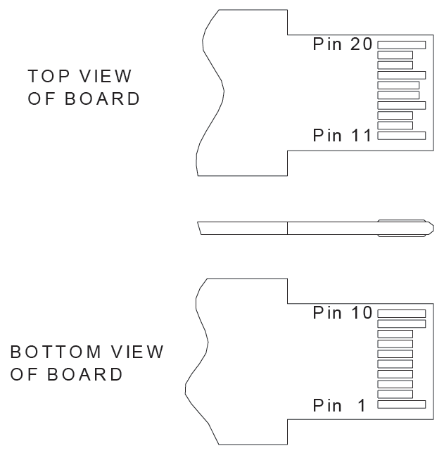

Pin | Symbol | Level / Logic | Description
1 | VeeT |  | Module Transmitter Ground
2 | Tx_Fault | LVTTL-O | Module Transmitter Fault Indication
3 | Tx_DIS | LVTTL-I | Transmitter Disable; Active High Disable Transmitter Output
4 | SDA | LVTTL-I | 2-Wire Serial Interface Data Line
5 | SCL | LVTTL-I/O | 2-Wire Serial Interface Clock
6 | MOD_ABS | LVTTL-O | Module Absent, connected to ground in the module
7 | RS0 |  | Not Connected
8 | RX_LOS | LVTTL-O | Loss of Receiver Signal Indication
9 | RS1 |  | Not Connected
10 | VeeR |  | Module Receiver Ground
11 | VeeR |  | Module Receiver Ground
12 | RD- | CML-O | Receiver Inverted Data Output
13 | RD+ | CML-O | Receiver Non-Inverted Data Output
14 | VeeR |  | Module Receiver Ground
15 | VccR |  | Module Receiver 3.3V Supply
16 | VccT |  | Module Transmitter 3.3V Supply
17 | VeeT |  | Module Transmitter Ground
18 | TD+ | CML-I | Transmitter Non-Inverted Data Input
19 | TD- | CML-I | Transmitter Inverted Data Input
20 | VeeT |  | Module Transmitter Ground
Notes:
1.When high, this output indicates a laser fault of some kind. Low indicates normal operation. And should be pulled up with a 4.7 – 10KΩ resistor on the host board.
2. TX disable is an input that is used to shut down the transmitter optical output. It is pulled up within the module with a 4.7 – 10KΩ resistor. Its states are:
Low (0 – 0.8V): Transmitter on (>0.8, < 2.0V): Undefined
High (2.0V~Vcc+0.3V): Transmitter Disabled Open: Transmitter Disabled

3.Mod-Def 0,1,2. These are the module definition pins. They should be pulled up with a 4.7K – 10KΩ resistor on the host board. The pull-up voltage shall be between 2.0V~Vcc+0.3V.
Mod-Def 0 has been grounded by the module to indicate that the module is present
Mod-Def 1 is the clock line of two wire serial interface for serial ID
Mod-Def 2 is the data line of two wire serial interface for serial ID

4.When high, this output indicates loss of signal (LOS). Low indicates normal operation.

5.RD+/-: These are the differential receiver outputs. They are AC coupled 100Ω differential lines which should be terminated with 100Ω (differential) at the user SERDES. The AC coupling is done inside the module and is thus not required on the host board.

6. TD+/-: These are the differential transmitter inputs. They are AC-coupled, differential lines with 100Ω differential termination inside the module. The AC coupling is done inside the module and is thus not required on the host board.

Diagnostics
Parameter | Symbol | Units | Min. | Max. | Accuracy | Note
Transceiver temperature | DTemp-E | ºC | -45 | +90 | ±5ºC | 1
Transceiver supply voltage | DVoltage | V | 2.8 | 4.0 | ±3%
Transmitter bias current | DBias | mA | 2 | 80 | ±10% | 2
Transmitter output power | DTx-Power | dBm | -3 | +8 | ±3dB
Receiver average input power | DRx-Power | dBm | -35 | 0 | ±3dB
Notes:
1.When Operating temp.=0~70 ºC,the range will be min=-5,Max=+75
2. The accuracy of the Tx bias current is 10% of the actual current from the laser driver to the laser
3. Internal/ External Calibration compatible.

Functional Diagram
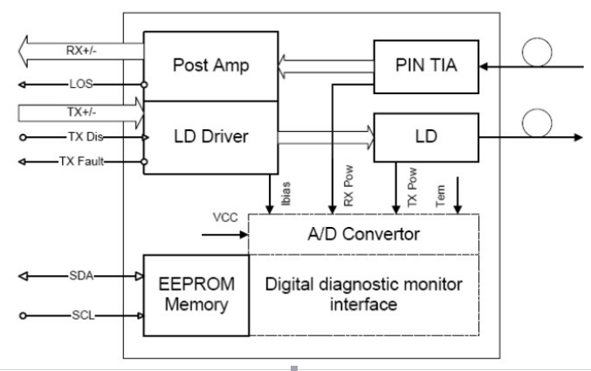

Typical Interface Circuit

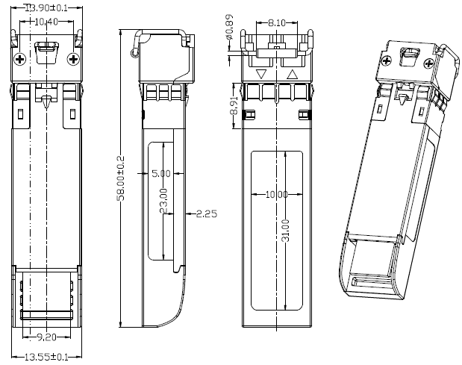
Package Dimensions

For More Information

FANG HANG TECH LIMITED
Office ：908 Room, Jingyuan Building, 28 Bulong Rd, Longgang District,Shenzhen. China
Tel: +86-755-89584520
Fax: +86-755-89584520
sales@fanghangtech.com
www.fanghangtech.com

